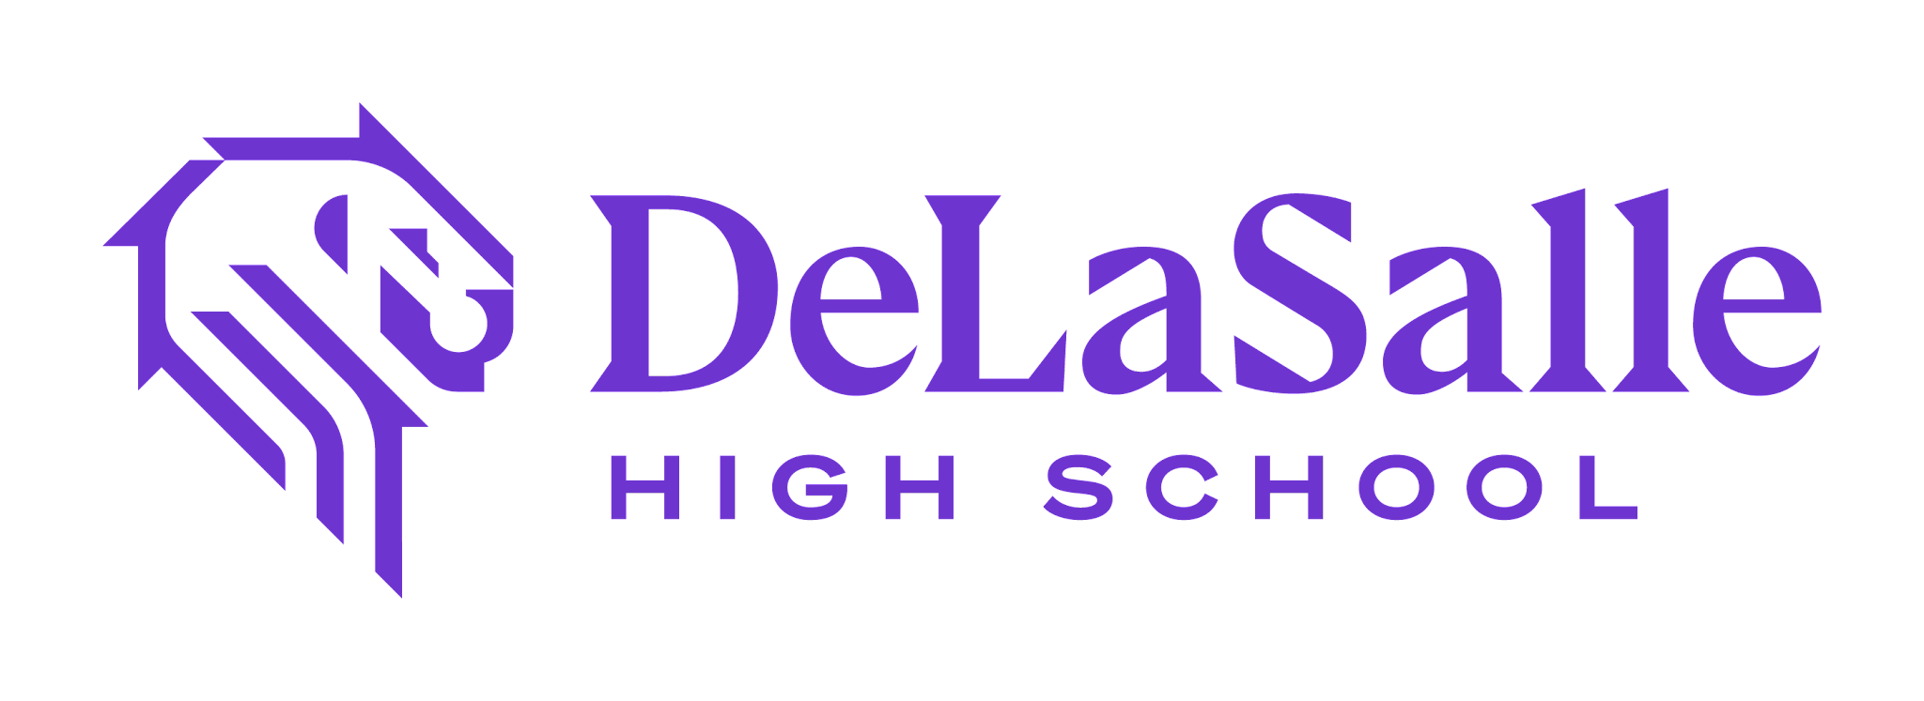 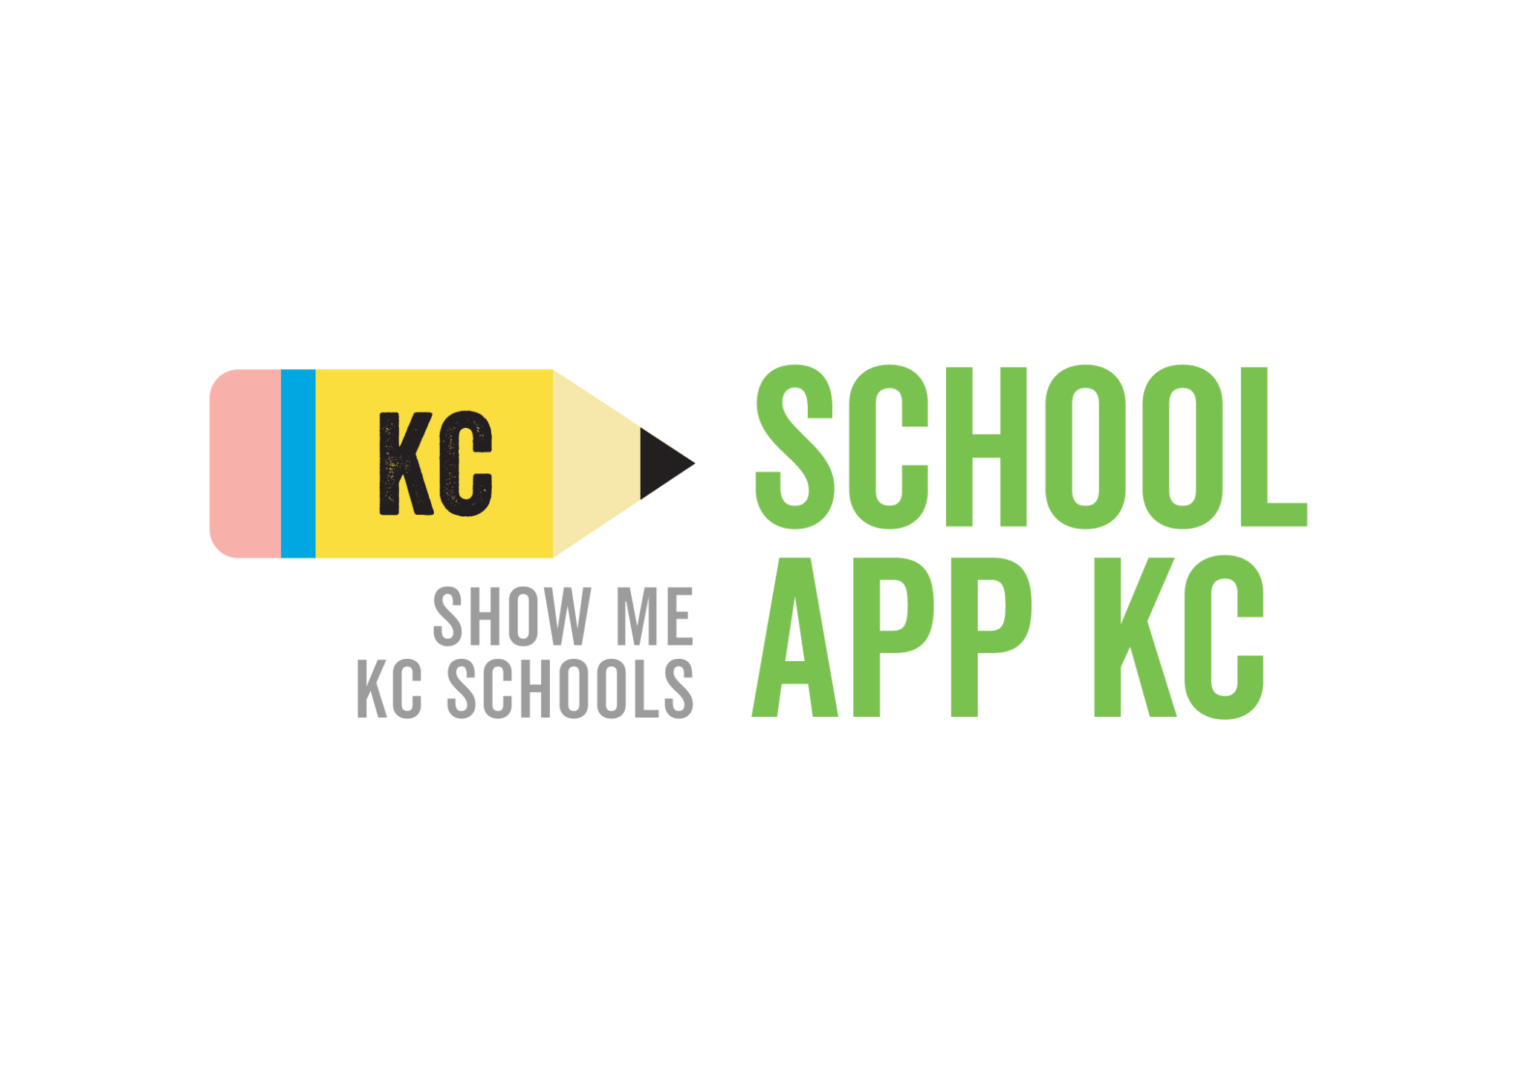

**Notice of Open Lottery**

For the 2025–26 school year, the lottery will be held on or before **March 6, 2025**. At that time you will know whether or not your child has been accepted or is on the waitlist.

**Important Note About Open Application**

The open application period for the 2025–26 school year will begin on **November 12, 2024** and conclude on **March 1, 2025**. Applications received after the open application period closes will be placed at the end of the waiting list.

Apply Today

*For the 2025-26 school year, all applications received will be placed at the end of the waiting list and an offer will be made when a seat becomes available.*

DeLaSalle Education Center is one of 16 Kansas City charter schools working together to simplify our initial application process into one easy form, SchoolAppKC, that you can fill out on any electronic device. The easy 8-question application allows you to apply to DeLaSalle in less than 5 minutes and makes applying to schools easier, more accessible and more transparent. To apply, go to SchoolAppKC.

**Important dates for application for 2025-26:**

* Applications open November 12th, 2024
* Submit your application by March 1st, 2025
* Receive an offer on March 6th, 2025
* Let us know you’re coming by March 13, 2025 and begin enrollment*

\**Note: If you have been waitlisted, you may choose to remain on our waitlist.* To apply, go to SchoolAppKC.